**Preparation of Papers for International Journal for Interdisciplinary Sciences and Engineering Applications (Book Antiqua ,18 Bold)**

**1First Author, 2Second Author , 3Third Author (Arial , 10 ,Bold)**

1Department ABC, University X, Country Y (Arial ,10 ,normal)

2Department MN, University Z, Country W

3Department MN, University Z, Country W

[zzz@uum.edu.my](mailto:zzz@uum.edu.my); [xxxx@yahoo.com](mailto:xxxx@yahoo.com); yyy@gmail.com

**ABSTRACT**

**Here, the font is Arial of size 9. Please follow the instructions in this document to prepare abstract.** **The electronic file of your paper will be formatted further at IJISEA. Define all symbols used in the abstract. Do not cite references in the abstract. Do not delete the blank line immediately above the abstract; it sets the footnote at the bottom of this column. Don’t use all caps for research paper title.(Arial Size 10 Bold)**

**Key words:** important, key, words, used, Minimum 7 keywords are mandatory, Keywords should closely reflect the topic and should optimally characterize the paper. Use about four key words or phrases in alphabetical order, separated by commas. (Arial size 10 normal)

**Abbreviations:** FFR, False Rejection Ratio; DAA, Decimal Adjust Addition (Arial size 10 normal)

**I.INTRODUCTION**

Sub-section heads or secondary headings flush left, bold, 11-point in upper and lower case as shown. For subsection heads, a word like “the” or “a” is not capitalized unless it is the first word of the header.

**1. SIDE HEADING:** Detailed submission guidelines can be found on the author resources Web pages. Author resource guidelines are specific to each journal, so please be sure to refer to the correct journal when seeking information. All authors are responsible for understanding these guidelines before submitting their manuscript. For further information on both submission guidelines, authors are strongly encouraged to refer to <https://www.ijisea.org> (Arial size 10 normal) (Arial size 10 normal)

**2. SIDE HEADING:** Detailed submission guidelines can be found on the author resources Web pages. Author resource guidelines are specific to each journal, so please be sure to refer to the correct journal when seeking information. All authors are responsible for understanding these guidelines before submitting their manuscript. For further information on both submission guidelines, authors are strongly encouraged to refer to <https://www.ijisea.org> (Arial size 10 normal)

**II.RELATED WORK**

**1. FIRST SECTION:** Detailed submission guidelines can be found on the author resources Web pages. Author resource guidelines are specific to each journal, so please be sure to refer to the correct journal when seeking information. All authors are responsible for understanding these guidelines before submitting their manuscript. For further information on both submission guidelines, authors are strongly encouraged to refer to <https://www.ijisea.org> (Arial size 10 normal)

**1.2 MIDDLE SECTIONS:** For papers accepted for publication, it is essential that the electronic version of the manuscript and artwork match the hardcopy exactly! The quality and accuracy of the content of the electronic material submitted is crucial since the content is not recreated, but rather converted into the final published version. (Arial size 10 normal)

1. All papers in IJISEA Transactions are edited electronically. A final submission materials check list, transmission and compression information, and general publication materials can be found at: <https://www.ijisea.org>
2. All papers in IJISEA Transactions are edited electronically. A final submission materials check list, transmission and compression information, and general publication materials can be found at: <https://www.ijisea.org>

**2. FINAL SECTIONS:** As demonstrated in this document, the numbering for sections upper case Arabic numerals, then upper case Arabic numerals, separated by periods. Initial paragraphs after the section title are not indented. Only the initial, introductory paragraph has a drop cap.

**III.METHODOLOGY**

If you are using Word, use either the Microsoft Equation Editor or the Math Type add-on (http://www.mathtype.com) for equations in your paper (Insert | Object | Create New | Microsoft Equation or Math Type Equation). “Float over text” should not be selected. (Arial size 10 normal)

Number equations consecutively with equation numbers in parentheses flush with the right margin, as in (1). First, use the equation editor to create the equation. Then, select the “Equation” markup style. Press the tab key and write the equation number in parentheses. To make your equations more compact, you may use the solidus ( / ), the exp function, or appropriate exponents. Use parentheses to avoid ambiguities in denominators. Punctuate equations when they are part of a sentence, as in (Equations are Times new roman Italic size 10 normal)

|  |  |
| --- | --- |
| *p*(*x*) $=$ | (1) |
|  |  |
| *q*(*x*) $=$ 1 $-$*p*(*x*) | (2) |

Please note that math equations might need to be reformatted from the original submission for page layout reasons. This includes the possibility that some in-line equations will be made display equations to create better flow in a paragraph. If display equations do not fit in the two-column format, they will also be reformatted. Authors are strongly encouraged to ensure that equations fit in the given column width.

**IV.RESULTS**

Figures (graphs, charts, drawing or tables) should be named figure 1.eps, figure 2.ps, etc. If your figure has multiple parts, please submit as a single figure. Please do not give them descriptive names. Author photograph files should be named after the author’s last name. Please avoid naming files with the author’s first name or an abbreviated version of either name to avoid confusion.

If a graphic is to appear in print as black and white, it should be saved and submitted as a black and white file (grayscale or bitmap.) If a graphic is to appear in color, it should be submitted as an RGB color file.

**Table 1:** Sample of transformed rainfall data.

|  |  |  |  |
| --- | --- | --- | --- |
| **Rainfall data** | **Normalized classes** | **Linguistic variable** | **Fuzzy discretization** |
| 172.10 | 0.08 | Very low | 1 |
| 173.33 | 0.13 | Very low | 1 |
| 175.88 | 0.24 | Very low | 1 |
| 176.15 | 0.25 | Low | 2 |
| 178.54 | 0.35 | Low | 2 |
| 181.65 | 0.49 | Moderate | 3 |
| 183.19 | 0.55 | Moderate | 3 |

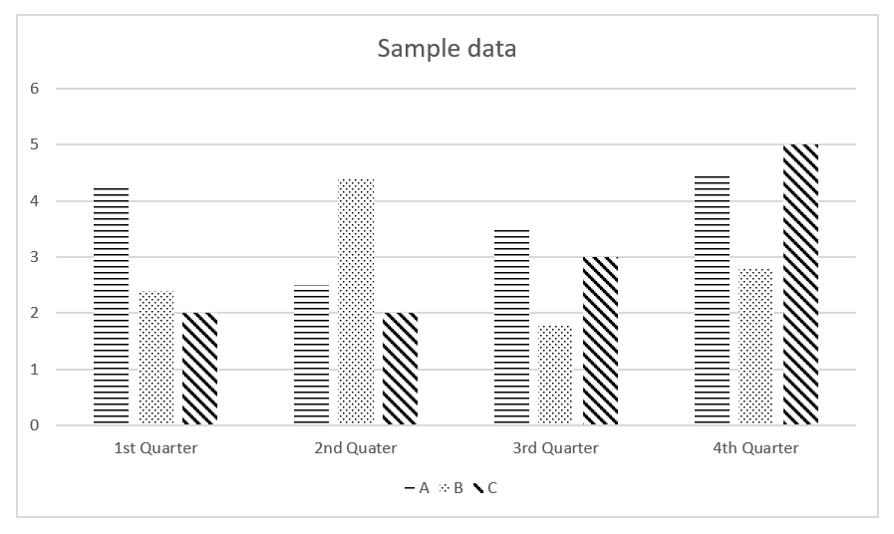

**Figure 1:**  An example of chart represented in shaded pattern.

**V.CONCLUSIONS**

Although a conclusion may review the main points of the paper, do not replicate the abstract as the conclusion. A conclusion might elaborate on the importance of the work or suggest applications and extensions. Authors are strongly encouraged not to call out multiple figures or tables in the conclusion—these should be referenced in the body of the paper.

**VI.DISCUSSIONS**

Although a conclusion may review the main points of the paper, do not replicate the abstract as the conclusion. A conclusion might elaborate on the importance of the work or suggest applications and extensions. Authors are strongly encouraged not to call out multiple figures or tables in the conclusion—these should be referenced in the body of the paper.

**ACKNOWLEDGEMENT(S)**

The authors wish to thank A, B, C. This work was supported in part by a grant from XYZ.

**REFERENCES :** List of references shall follow the latest APA Style.